Mount Pleasant Rotary Club
P.O. Box 252
Mt Pleasant, MI 48804-0252
Website: mprotary.com
Facebook: Mt. Pleasant Rotary Club
Rotary Roundup August 14, 2017

Recap of August 7th, 2017 Club Meeting
Carol Santini called the meeting to order and we had no flag for the Pledge of Allegiance.
Invocation: Bob Wheeler
Greeters: None
Birthdays: Rebecca Alter: Aug 7th, Connie Lynch: Aug 9th, Eileen Jennings: Aug 11th, Bethany Ervin: Aug 13th, Mark Hamouth: Aug 15th, Bob Wheeler: Aug 15th, Robin Duthie: Aug 18th, Emelia Parker: Aug 20th, Alysha Anders: Aug 28th.
Guests: Al Slaggert

Announcements:
- Jena spoke about the Rotary Run/Walk/Fun Run. Registrations are down and they are still in need of sponsors.
- Robin reminded us that the Rotary Auction has been scheduled for Tuesday October 17th. Start collecting donations.
- There is a board meeting this Wednesday at 12.

Music: “God Bless America” led by John Schneider, Associate Professor at CMU for Department of Biology.
Sergeant-at-Arms: None

Fines & Braggs:
- A pass for this week due to tour.

Program:
John Schneider, Tracy Galarowicz, PhD and Eric Clinton, PhD of the biology department at CMU toured three groups of Rotarians around the new Bio Science building at CMU. This building was the most expensive project CMU has undertaken at 95million dollars. It opened last year to professors and in January to students. They state it is “science on display” With living walls and aquariums throughout the building. They have two main functions- education and research. The facility houses 6 teaching labs, large lecture halls, and an active learning classroom. Specialty research facilities within the building include a vivarium to replicate aquatic conditions for research, a molecular biology core, an isotope laboratory, an Imaging center for scanning and transmission electron microscopes, a herbarium, and a staging and processing fieldwork samples.

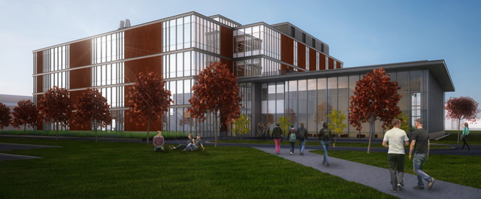
Photo compliments of Central Michigan University.

