**Mount Pleasant Rotary Club**

**P.O. Box 252**

**Mt Pleasant, MI 48804-0252**Website:[mprotary.com](http://www.mprotary.com/)

Facebook: Mt. Pleasant Rotary Club

**Rotary Roundup October 2, 2017**

##### Recap of September 25th, 2017 Club Meeting

***Carol Santini*** called the meeting to order and lead us in the Pledge of Allegiance.

***Invocation:*** David Martin Stevens

***Greeters:*** Betsy Fagan

***Guests:*** None

***Announcements:***

* Jasmine received her Paul Harris Fellowship and Tom Miles received his 6th one! Way to go Rotarians!
* Rich Fleming attended a Rotary Club in Tucson, AZ and presented Carol with their banner.
* Peggy Pickler informed us that we received two district grants. One for $12,000 for the Women’s Shelter and one for Rotary Rewards in the amount of $11,000.
* Paul Siers shared that our Zambia project has finally been cleared to proceed, but not we need to raise $3,000 for the project since prior commitments had backed out in the meantime. He also reminded everyone that order forms for the Michigan Gift Baskets are available.
* Robin Duthie told us that the deadline for the auction items is this Friday.

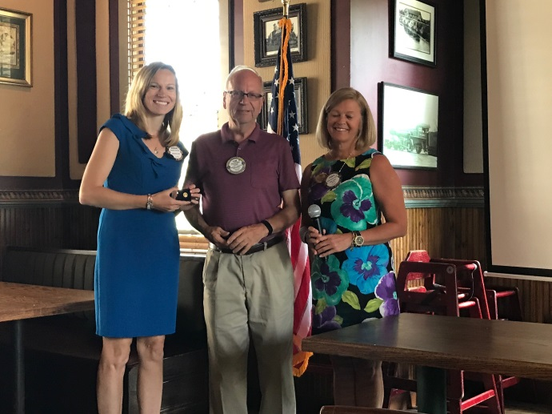

**Music:** Eileen Jennings led us in *“Roll Rotary”.*

**Sergeant-at-Arms**: Peggy Pickler

**Fines & Brags:**

* Tom Olver congratulated Dave Keilitz for winning a CMU alumni award last week.
* Paula was fined for mispronouncing Jasmine’s last name.
* Krystal bragged that it was great to have two daughters in the same sport and that they had both lettered in the same event at their last swim meet.
* Eileen thanked Peggy for allowing them to put up an Applefest sign in front of her business.
* Amanda reminded everyone of the Look Who’s Talking event coming up on October 10th.
* Jayme informed everyone that her little one is now walking! Oh, there is going to be trouble now. ☺
* Carol bragged that Rotary is everywhere. She saw an outbound Rotary exchange student on her flight to Italy and while there saw an exhibit sponsored by a local Rotary Club.

**Program:**

Today’s program was about Christmas Outreach and was presented by our own Peggy Burke. Christmas Outreach has been going for 37 years. Their mission is to coordinate community resources for Christmas giving. They used to accept any clothing but have switched to only new or gently used items. Last year they gave out 2,000 coats to about 400 families. They have always had trouble getting coats in sizes 3X to 5X, so they use grant money to purchase extras in these sizes. They used to collect and give out toys, but since another charitable organization does that, they have switched to giving out books, which the Mount Pleasant Area Community Foundation helps them with. The United Way has stopped doing the Adopt-a-Family program and now coordinates with Christmas Outreach to provide baskets of household cleaners. In addition to coats, kids also get a Christmas stocking with items such as matchbox cars, crayons, coloring books, wooden toys (made by our local woodworkers group), school supplies, and stuffed animals. The teens get a gift bag with personal hygiene item. Last year Christmas Outreach gave out about 450 stockings and 450 gift bags. They have about 280 volunteers help distribute items and about 50 people help get everything organized. They have a budget of $35,000. They will be collecting items at Finch Field House December 4-7 and will be distributing items on December 8-9.

