Mount Pleasant Rotary Club
P.O. Box 252
Mt Pleasant, MI 48804-0252
Website: mprotary.com
Facebook: Mt. Pleasant Rotary Club
Rotary Roundup
November 27th, 2017

Recap of November 20th, 2017 Club Meeting
Carol Santini called the meeting to order and lead us in the Pledge of Allegiance.
Invocation: David Stevens
Greeters: Charlie Kinzel & Jayme LaRose
Guests: Tia Fedor, Granddaughter of Ken Schaeffer
Music: Robin Duthie led us in Happy Birthday to Corey Friedrich, Mike Pittsley, Richard Divine and Amy Powell and “Let There Be Peace on Earth”.
Announcements:
- Carol Santini spoke regarding the Rotary Gala. The Club won awards for our support of Polio Plus and Every Rotarian Every Year campaigns.
- Peggy Pickler let us know that the Community Service Committee and then the Rotary Board met and approved awards to Christmas Outreach, the Infant Pantry and an additional 2K in donation to the amphitheater project in the park.
- Paul Siers reminded us orders are able to be placed for the Michigan Gift Boxes. There are two sizes- a $20 five item box and a $35 nine item box. He reminded us all that these support local businesses.
- Kathy Beebe brought Roterac student, Abbey Zahn who is very active in Rotary Sponsored events. She gave an update on the Roterac Club and her recent trip to Dominican Republic with Tom Miles and District 6310.
- Bethany Ervin was announced as being the recipient of the Eagle Award for her great service to this community.
- Dave Keilitz let us know the committee to elect of the distinguished citizenship and vocational excellence awards will meet next week and decide on the winners.
- The beef dinner is approaching and is scheduled February 9th. More info to come soon.

Sergeant-at-Arms: Tom Olver
Fines & Brags:
- Tom Olver saw the list of fines he had from last week and chose to go only with brags this week, beginning with his own for all the teams who danced in Dance United raising $56,000 for the community. The next day another $6,000 was raised at the Fill a Mayflower Event.
- Peggy Burke bragged on behalf of this great community and all the support she has seen for the members and the United Way. They raised and exceeded their goals for Pack the Pantry raising $24,000. She also thanked the Club for raising the funds to buy the books this year for Christmas Outreach.
- Bethany Ervin bragged on behalf of the 80 member 4H Club, the Evergreens and all their hard work serving Thanksgiving Dinner to the residents of Rosebush Manor.
- Lisa Hadden bragged that the Mid Michigan Cycling Club will be hosting the Michael Seaman Frost Cross, Saturday, December 2nd at Deerfield Park. Public is welcome to come watch this fun event, there will be food trucks.
- Jay Anders Bragged that this year the ICCU will again be hosting the annual Pie Sale this Tuesday and Wednesday.
- Alysha Anders Fisher bragged for her dad as he is awesome and helped her and her mother repaint her house.
- Ken Schaeffer bragged on Eileen Jennings who did an amazing job putting together this year’s Rotary Gala. Thank you Eileen for all your do for Rotary!

Program:
Jay Anders presented the Student of the Month presentation. These students are nominated by their teachers, selected by the administration and become eligible for 1 of 3 $750 scholarships that the Club will award in May.
Sarah Millerov was first up from Beal City Public Schools. She presented Shelby Trevino. Her parents are Joe and Crissy Haupt. She has a 4.0 GPA. She is involved in NHA, youth and government, Volleyball, Softball and is an active volunteer in the community. Her plans are to attend CMU next year and study the Physician Assistant Program.

Mary Kay Younkers presented Nicholas Zeien from Sacred Heart Academy. His parents are Danielle and Mike Zeien. He has a 3.93 GPA. He is involved in NHS, Track, the Senior Homecoming King, Model UN, a kindergarten classroom aid and has logged over 700 hours of community service. He also plans to attend CMU next year studying the Medical Field or Elementary Education.

Jeff Platte from Mt Pleasant High School presented Sana Gala. Sana is the Interact Club Presidents, Vice President of the Student Senate, a tennis player, active in Diversity Council, leadership conferences and does lots of volunteering in the community. Her mother Parveeza Gala supported her today. She also plans to attend CMU, hopefully entering the Honors Program and studying biosciences.
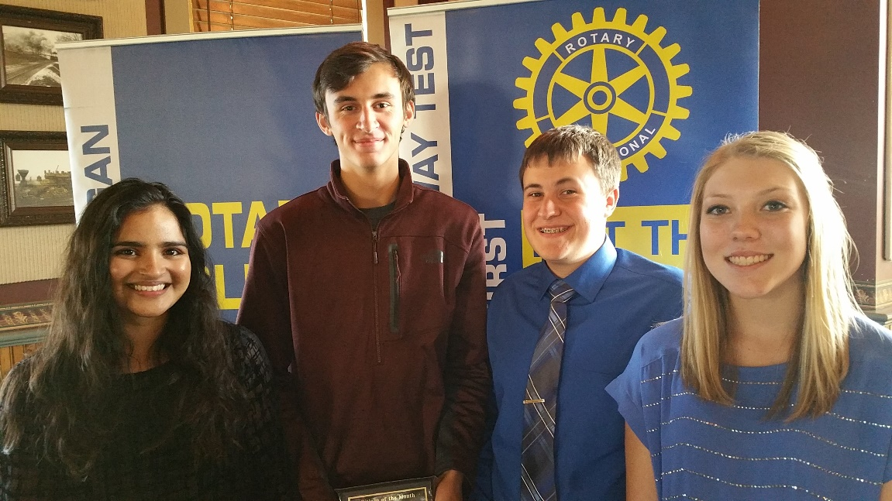
Jeff also presented Gage Shellenbarger. Gage has participated in 4 years of Track, taken college courses while completing his high schooling, does lots of volunteering, guitar playing, and just signed as a Division 1 athlete in Track at CMU. His parents are Barry and Julie Shellenbarger. His plans next year are to attend CMU participating in the decathlon and studying physical therapy.

