Mount Pleasant Rotary Club
P.O. Box 252
Mt Pleasant, MI 48804-0252
Website: mprotary.com
Facebook: Mt. Pleasant Rotary Club
Rotary Roundup
February 12th, 2018

Recap of February 5th, 2018 Club Meeting
Carol Santini called the meeting to order and lead us in the Pledge of Allegiance.
Invocation: Paul Siers
Greeters: Ken Schaeffer and Rebecca Salter
Guests: Megan Potts from Boy Scouts of America guest of new member, Stephanie Bird
Music: Kathy Beebe led us in Happy Birthday to Tom Gross and Vanessa Spratt “Country Roads”.
Announcements:
- Thank you was received from the Community Compassion Network for the Grant they received.
- We also received an invite from the Mt Pleasant Discovery Museum for the Bowties and Bourbon fundraiser they are having at the Courtyard at Marriott. See Carol if you want more info.
- Mark Homuth let us know we are good to go for the beef dinner this Friday. Arrival times are 1:30 PM for To Go, 3PM for Dessert, 3:15 for Greeters, tickets sales, and servers, 3:30 for carvers and food line and 4:15 and 5:15 for dishwashers. Dress code with white shirts and black pants (unless you are a dishwasher).
- Alysha Anders-Fisher updated that sponsorships have totaled $18,750. Lost 8 sponsors from last year.
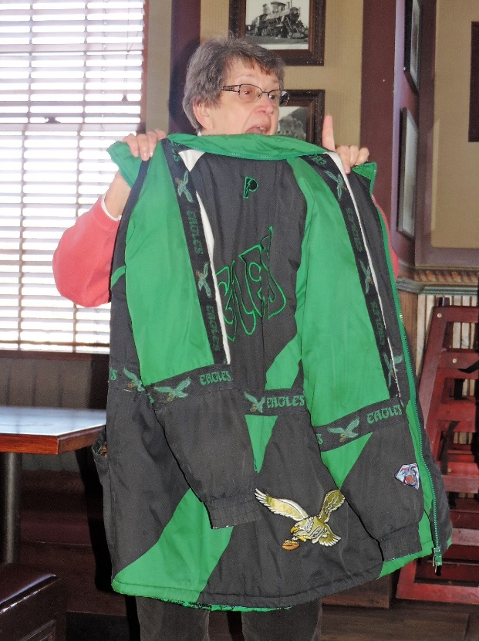
- Eileen Jenningslet us know that our meeting next week will be our Valentines Celebration and Rotary Estate Planning.
Sergeant-at-Arms: Peggy Pickler
Fines & Brags:
- Amy Powell was fined for being the consolation at the comfort Inn and Rachel Blizzard also for being the top ten at the Optimists fundraiser Saturday.
- John Hoerauf was fined for being new and going to Hawaii.
- Connie Lynch was fined for her phone going off during meeting.
- Betsy Fagen bragged that she is a self appointed fashionista today and is in love with Kim Seidel and Jasmine Eichinger who always offers her coat. She had brought her sons coat that she had since he was in 7th grade and wears when doing chores which was an Eagles jacket.

Program:
Amy Ervin did the induction of 2 new member- Vanessa Sprat who contacted us via our website, sponsored by Amy Ervin and Stephanie Bird who was sponsored by Kathy Beebe.

Stephanie Bird is from Battle Creek where her father owns a small print ship. Her mom works in a medical office. She has a sister who lives out of state and is a physical trainer. She went to CMU where she has been very active with Roterac- including being the club President. She was also a counselor with RYLA. She worked at Listening Ear and currently is part of the Boy Scouts of America Heartland District. She assists in Clare, Midland, Gratiot, Isabella and Gladwin Counties working to increase awareness and participation in scouting.

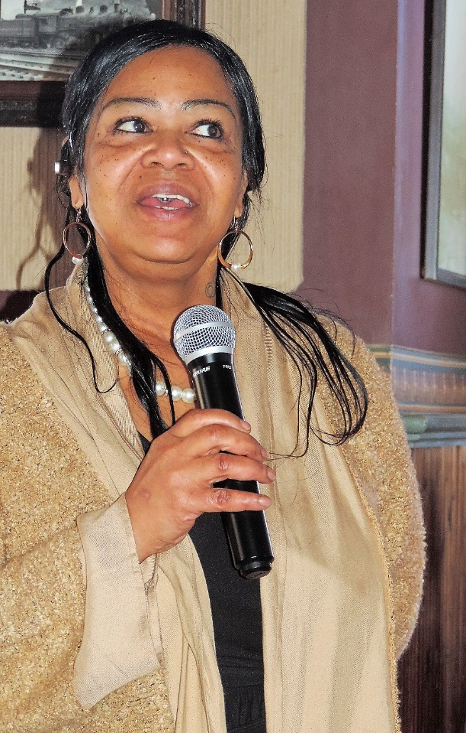

Vanessa Spratt moved here in 2012 to be closer to her grandkids. She has a daughter who is married to a Marine. She established Soul Sisters LLC for soul food and baking. She has three daughters age 36,27, and 25 as well as 2 grandchildren, a boy and a girl. She is married and from Inkster, MI. In the Dearborn Heights area she was a president at Rotary. She loves to sing. Her dream was to own a restaurant. She will be 56 tomorrow. Currently her peach cobbler is available at Crankers and Faith Community Church when she hosts Fellowship Sunday. January 15th was a fundraiser to open her restaurant. She now has the funds and is waiting on the Health Department to do the final approval and open for take out. She over came many struggles to open and will be located at 1010 West Broadway. She will serve soul food such as peach cobbler, fried chicken, ribs, meatloaf, etc.

Welcome to the Mt. Pleasant Rotary Club!! We are very happy to have you.

