Mount Pleasant Rotary Club
P.O. Box 252
Mt Pleasant, MI 48804-0252
Website: mprotary.com
Facebook: Mt. Pleasant Rotary Club
Rotary Roundup
November 13th, 2017

Recap of November 6th, 2017 Club Meeting
Carol Santini called the meeting to order and lead us in the Pledge of Allegiance.
Invocation: Bob Wheeler
Greeters: Charley Kinzel and John Jensen
Guests: Paula Arndt’s Son joined her today
Music: Kathy Beebe led us in Happy Birthday to Randy Dickinson and “America the Beautiful”. Kathy also included the history of the song for us all to read.
Announcements:
- Robin Duthie reminded everyone of the distinguished citizenship and vocational excellence award, due in today, please turn these nominations into her or Dave Keilitz.
- Jay Anders auctioned off the remaining items from the Rotary Auction.
- Carol Santini thanked all our Veterans for their service to our Country. Charley Kinzel, Tony Delellis and Chad are all veterans.
- Amy Ervin let us know the Fireside Chat was cancelled for this week. We will reschedule for a later date.
- Anyone interested in nominations for the Board please let Robin Duthie or Carol Santini know.
- Jena Eisenberger has the last 4 years of Rotary Run T shirts available for 5$ each. See Jena to get them.
- This Wednesday will be a Board meeting- Noon at the Community Foundation.

Sergeant-at-Arms: John Jensen
Fines & Brags:
- Tom Olver was fined for forgetting he was sergeant.
- Tom Miles was fined for walking in with his badge already on.
- Jen Eisenberger was fined for having ads with her picture in the paper. She will be having a Veteran’s luncheon at the Shepherd Bar.
- Kim Seidel was also fined for having her picture in the paper.
- Tom Olver also bragged that Dance United is next Thursday- VIP hours is from 6p-7p and the show starts at 7pm.
- Jena Eisenberger bragged that she will be hosting a Women’s Seminar at Cheers Wednesday November 8th from 5:30 to 7pm.
- Mark Homuth bragged about his song and the great service he is providing to the community as a Law Enforcement Agent.
- Lisa Hadden bragged that the Mid Michigan Cycling Club will be hosting the Michael Seaman Frost Cross, Saturday, December 2nd at Deerfield Park. Public is welcome to come watch this fun event.

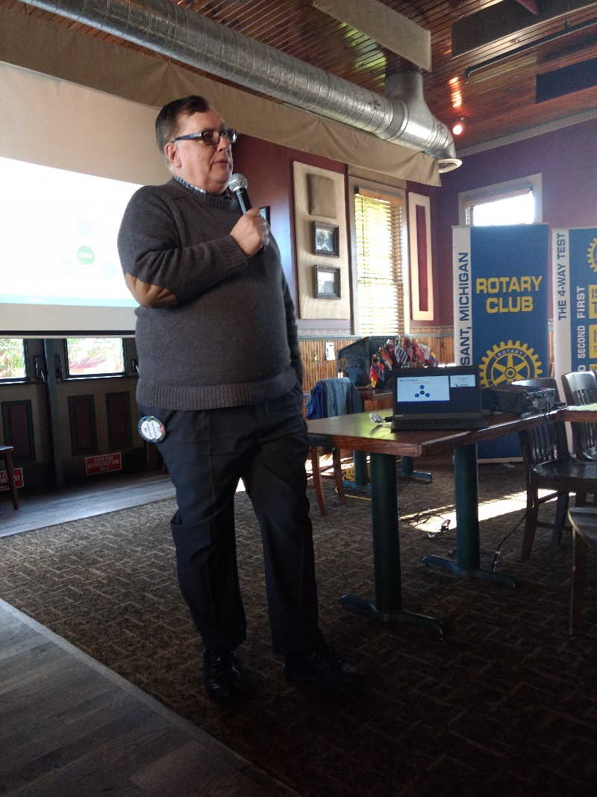
Program: Jim McBryde presented on behalf of the Middle Michigan Development. Jim toured us through the updated website. He spoke about changes to the site consultants and updates to available properties. They have created their own real estate listing per feedback of users to make the system more user friendly. There are now links to PDF to printable listing sheets as well. You can visit the website at www.mmdc.org. They serve the Clare and Isabella Counties and Jim has been there 2.5 years. They are the only 2 county partnership in Michigan. He feels this is a great relationship. He spoke on Site Consultants who are “site eliminators” who help companies select the best locations to start business in. There are only about 50-60 official site consultants in the USA. They review multiple elements including famous brands- ie. Morbark and Bandit Industries being world leaders in wood/waste products, leader of commercial kitchen equipment- Delfield, Wildlife Gallery- largest animal tanning in the world, Supply Chain Supply- Alro Steel, Amazing Success Stories such as Cops and Donuts (who now employs 200 people), Vocational and College support- CMU, Mid-Michigan community College and Gratiot Isabella Technical Schools, etc. They also sell companies on Mt Pleasant as a largest City, Middle Michigan lifestyle, Entertainment and Draw of family fun places- waterpark, Rocks and Valleys, breweries.

Jim spoke about what keeps him up at night and those items include a lack of population increase in Michigan, a -6% of Millennials staying in the area. He spoke to possible solutions such as retaining 25% of CMU grads to the area would correct the workforce deficit, 50% would provide a better margin of workers. He also spoke about Clare being at a 6% unemployment rate and a 4% rate in Mt Pleasant which is practically a 0% unemployment rate. His goal is to get our business to students first before other companies. Additionally, CMU has removed caps on students in the program and MidMichigan is working diligently to increase the amount of vocational students they can accommodate. He ended by telling us all that people should not keep pushing just college as the skilled trades are also great job security and sources of income.

