Mount Pleasant Rotary Club
P.O. Box 252
Mt Pleasant, MI 48804-0252
Website: mprotary.com
Facebook: Mt. Pleasant Rotary Club
Rotary Roundup
November, 6th 2017

Recap of October 30th, 2017 Club Meeting
Carol Santini called the meeting to order and lead us in the Pledge of Allegiance.
Invocation: Tom Miles
Greeters: Stephanie Hope
Guests: John Hocrauf from MID and Julie from the Rotaract club

Announcements:
- The Interact students were able to raise $455 through the purple pinkie project. They added to it by selling hot chocolate to students as well. $305 was made in school, $150 from the club.
- Next Monday they will be auctioning off the final items that did not get purchased at the auction.
- Paul said his work on the Zambia project is finally done! He mailed the check to Chicago! The project raised a total of $55,500. $10,241 was contributed from our club.
- Julie shared information on the statewide conference that the Rotaract student participated in and some of the other events they have going on currently.
  - They have helped with parks and recreation, worked with women’s aide as well – partnering with them on different events throughout the year. They currently have their Superbowl tickets for sale. 1 for $5 or 5 for $20
- Bob let everyone know that the bills for the 3rd quarter are out – please pay him!
- Carol reminded everyone that the slate for new officers needs to be in by December.

Music: John Jensen – Take me out to the ball game

Sergeant-at-Arms: Bob Wheeler

Fines & Brags:
- John got to talk about his Hawaiian trip in 20 words
- Bob had Rebecca and Rich’s name badges, they had to buy them back for $1.
- Tom Olver talked to us about the 6th annual Dance United taking place November 16th.
- Tom also bragged that he ran a half marathon with his girlfriend on Mackinaw Island over the weekend.
- Alysha bragged about her 9 years old son who is trying to earn money for his travel baseball team – he raised over $200 this weekend returning cans. If anyone would like to get rid of their cans – he can take them off your hands!

Program: Cindy talked about the Saginaw Children’s Zoo

Facts about the Zoo:
- Established in 1929
- They are a not for profit organization, providing a fun and safe place for children and families to visit.
- They were accredited by the AZA in 2009 & 2014.
- They focus on conservation, education, science and recreation.
- They house over 100 animals.
- They are held to the highest stand in animal care.
- The Zoo has spent close to $170 million on research and conservation .
- In 2016 they had over 100,000 visitors – a record breaking year.
- In 2017 so far; guests have visited from over 48 states – investing about $37 million into the local economy.
- Their staff consists of science professionals – providing the best personal care available.
- They are also invested and committed to a global breeding program – a species survival plan.
- Future: based on the needs of the community, members and volunteers:
  - Plan to re-introduce their train – refurbished - handicapped accessible!
  - Create learning centers, expand their concessions, create more interactive areas.
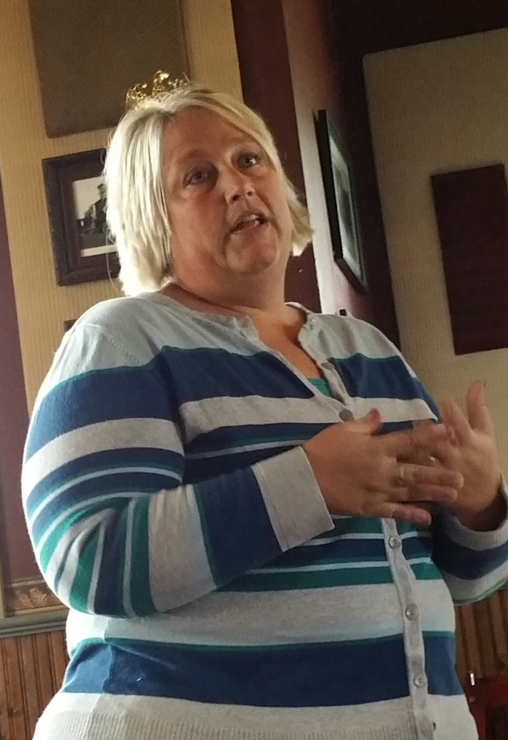
  - Create a ‘Family Nature Club’ – free program reaching out to the underserved community.
- Largest demographic: Tuscola, Isabella, Saginaw, Midland and Bay counties.
- Their official close date is Oct. 6 – staying open 3 weeks longer for Zoo Boo
- In November you can go back and see the Holiday Lights – free to the public.

