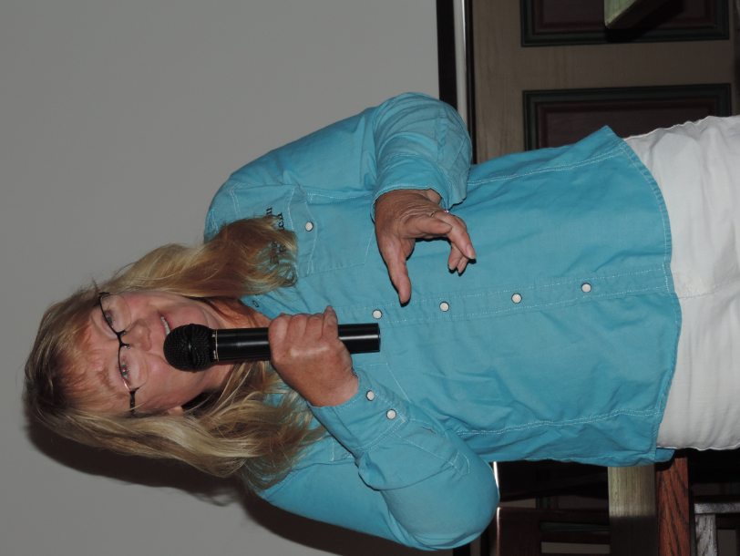
Jodi Stuber speaks to the Club about Hopewell Ranch

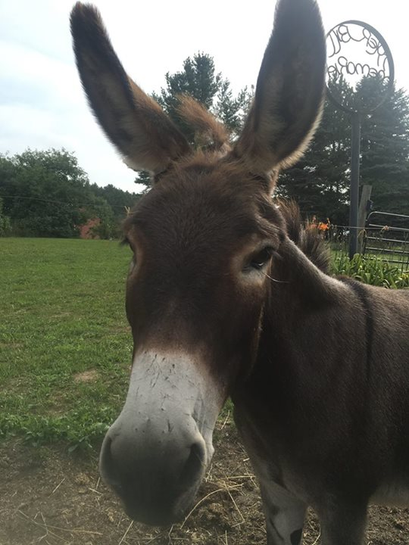

Puzzle Jack, therapeutic donkey at Hopewell Ranch

Mount Pleasant Rotary Club
P.O. Box 252
Mt Pleasant, MI 48804-0252
Website: mprotary.com
Facebook: Mt. Pleasant Rotary Club

Rotary Roundup September 12, 2016

Recap of August 29, 2016 Club Meeting

Robin Duthie called the meeting to order and lead us in the Pledge of Allegiance.
Invocation: Bob Wheeler
Guests: PDG Al Slaggert; Amy Powell of Art Reach; John Moolenaar, US Congressman and staffer Tom Smith
Greeters: Jim McBryde assisted by Ken Schaeffer & Rich Fleming
Bulletin Editor: Bob Wheeler
September Birthdays: Eisenberger, Jena--Sep 17; LaRose, Jayme--
Sep 19; McBryde, Jim--Sep 23

Announcements:
- US Congressman John Moolenaar attended and spoke briefly about his Rotary Connection. His daughter is a Rotary Exchange Student in Mexico now. He also offered to assist citizens as needed. He was in town today to present some awards posthumously to worthy veterans.
- Cheryl Petersen, our District Governor will be at the Club on Sept 19th.
- Pres. Robin announced that we need a volunteer to serve as Vocational Service Director on the Board. See her.
- Connie Lynch thanked all those Rotarians who served at the Community Compassion Network’s Mobile Food Pantry last Saturday, particularly those that got soaked! Way to take one for the team guys!
- Club voted to cancel the meeting next Monday, Labor Day, Sept. 5th with one nay vote—guess who? That’s right—Ken Schaeffer!
- Pres. Robin encouraged all Rotarians to read the district Dispatch when it comes to your inbox. It has a lot of information in it and nearly always features our club.

Music: John Jensen lead the group I singing “Home on the Range”

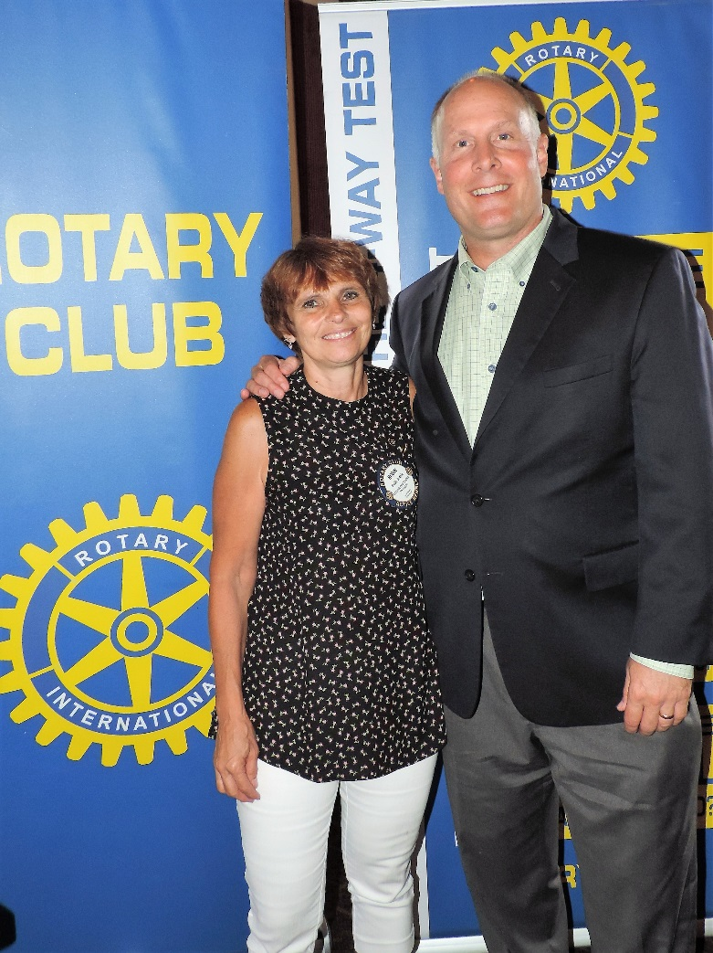
Rep. John Moolenaar with President Robin

Sergeant-at-Arms: Rich Fleming
Fines:
- Bob Wheeler was fined for some minor offense that this editor cannot even remember at this time!
- John Jensen was fined for maligning the club about their singing.
- Rotarians who were not wearing their pins were fined.
Brags:
- Pres. Robin announced that Grace is now engaged to her fellow Peace Corp volunteer.
- Kathy Hill announced that Art Walk Central will be going on for the next few weeks in spite of the rain. She also announced her retirement from Art Reach and the Club.
- Eileen announced that Israar, her Afghan son, and his family are moving to the US this week and will be staying with her until housing can be found.
- Mark Homuth bragged that his son Kyle starts his last semester at the policy academy today.
- Betsy Fagan returned from spending time with her grandchildren and announced that her grandson was going to invite 25 people over to bid her farewell. She saw thru that and cancelled the party.

Program:

Jodi and Ty Stuber spoke the club about Hopewell Ranch. They started the ranch in 2004 to provide free therapeutic horsemanship program for children who are physically, mental or emotional challenged. They just completed their 12th season.

They were sad to report that Bubba the affectionate Donkey passed away recently, but were pleased to announce that they are now home to Puzzle Jack, a miniature donkey who is now very popular and friendly. He is scheduled to go on tour to visit groups and children in the area soon. Hopewell currently has 18 therapy horses and have an indoor 100 x 200 foot riding facility.

Hopewell Ranch is now running a Veterans Program and finding success in helping people suffering with PTSD. They also run a fee based riding lessons, cabin Rental and birthday parties. However, they are largely dependent upon donations and are a United Way Agency. Jodi thanked the Club for its $1500 donation this year. They are in the process of implanting the grant on their new computer program.

Hopewell Ranch has a County Hoe Down Fundraiser at the Ranch on Friday, Sept 30th 6-9 pm. Cost $10 per person/$25 per family. Featuring Dinner, Dancing and Raffle.

