Mount Pleasant Rotary Club
P.O. Box 252
Mt Pleasant, MI 48804-0252
Website: mprotary.com
Facebook: Mt. Pleasant Rotary Club
Rotary Roundup
March 19, 2018

Recap of March 12th, 2018 Club Meeting
Carol Santini called the meeting to order and lead us in the Pledge of Allegiance.
Invocation: Jeff Inungu
Guests: Anna McDonald, Jennifer Eslink
Announcements:
- Board meeting at noon on Wednesday at COA.
- Thanks to Amanda for filling in for Carol at last week’s meeting.
- March is Reading Month assignments are out. Talk to Jasmine if you have any questions.
- Our inbound student still needs one host family for a three-month stint.
- Fireside Chat this Friday at noon at John Jensen’s house.
- Both the funds we have at the Community Foundation have money available to distribute this year. They are the annual scholarship funds we always give to deserving students and the Access to Recreation funds.
- In recognition of Women’s History month Eileen was recognized as one of the first female members of our local club.
- MMCC is having a fundraiser featuring a lot of food at Jay’s Sporting Goods in Clare. Tickets are $50.
Music: Bethany led us in “When the Saints Go Marching In”
Sergeant-at-Arms: John Jensen
Fines & Brags:
- Bethany was fined for singing too slow.
- Kathy Beebe invited the club to the Boy Scout Breakfast fundraiser Tuesday, April 3rd at 7:45 at the Comfort Inn. Our own Dave Keilitz will be the featured speaker.

Program:
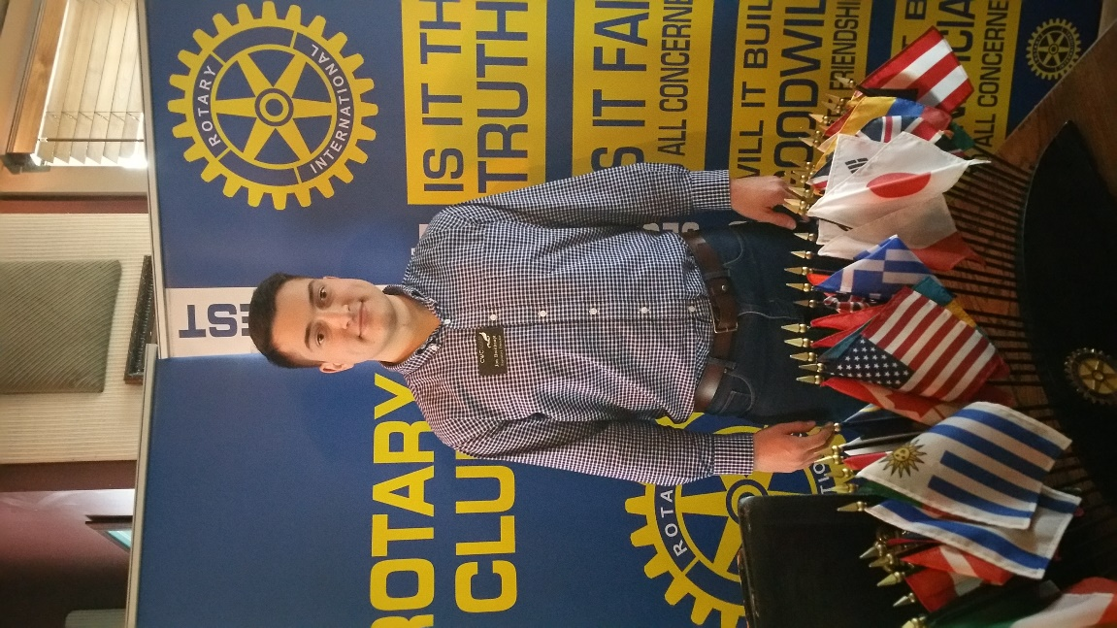
Jon Breithaupt from the Chippewa Watershed Conservancy was our featureds speaker today. Jon talked a little bit about the Conservancy and that kind of work they do there. Their mission is to protect wildlife habitat around the Chippewa River in their four county area. They have three tools that they use to accomplish this. The first is through conservation easements. Through this instrument a land owner can grant an easment on their property that would restrict what can be done on the property. The easment will then stay with the property in the future regardless of who owns it. The second thing they do is own land outright and as a conservancy open to the public. They offer educational and recreational programs on these properties. The last tool are government land transfers. In these cases the conservancy holds the land until it can be transferred to another government entity for its management. The offices of the conservancy are in the Hersey House and they have over 400 members interested in supporting their efforts. Their webite and facebook page list their calendar of events.

