Mount Pleasant Rotary Club
P.O. Box 252
Mt Pleasant, MI 48804-0252
Website: mprotary.com
Facebook: Mt. Pleasant Rotary Club
Rotary Roundup
November 20’^{th}, 2017

Recap of November 13th, 2017 Club Meeting
Carol Santini called the meeting to order and lead us in the Pledge of Allegiance.
Invocation: Bob Wheeler
Greeters: Dave Keilitz and Jeff Inungu
Guests: Bethany Ervin brought Jennifer Lincoln, her teammate from Great Lakes Caring and Quana Hoffman.
Music: Bethany Ervin led us in Happy Birthday to Tom Olver and “God Bless America”.
Announcements:
- Quana Hoffman spoke on her father’s life with Polio. He was diagnosed in 1948 at 4 years old and underwent many experimental surgeries however was unable to use one of his legs. However he went on to be a musician and graduate from CMU. She currently works as a teacher at the Saginaw Indian Tribal College and is available to anyone interested in additional information regarding Polio.
- Paul Siers reminded us orders are able to be placed for the Michigan Gift Boxes. He reminded us all that these support local businesses.
Ken Schaeffer reminded us to give to the Rotary Foundation for Polio Plus.
- Jena Eisenberger has the last 4 years of Rotary Run T shirts available for 5$ each. See Jena to get them.
- Carol Santini let us know that Eric Noeker has resigned from the Club. He has taken a different job in West Branch and was our current President Elect so the board is looking for a replacement.
- Dave Keilitz let us know the committee to elect of the distinguished citizenship and vocational excellence awards will meet next week and decide on the winners.

Sergeant-at-Arms: Tom Olver
Fines & Brags:
- Tom Olver fined himself as a leader for forgetting he was sergeant last week.
- John Jensen was fined for filling in for Tom last week.
- Jennifer Verleger was fined for submitting 58 applications for the United Way scholarships.
- Jay Anders was fined for not saying Hi to Tom while at a power broker breakfast at Stans.
- Betsy Fagan was fined for a conversation she had about the served lunch, the oddity of the tortilla chips on fish and suggesting they be used as soles of shoes. As a birthday present Betsy presented Tom with a take home serving of fish.
- Ken Schaeffer was fined because Tom has always wanted to do so.
- Rachael Blizzard was fined for being the leader in fundraising for Dance United.
- Bob Wheeler was fined for his Son Andy Wheeler being in second place for Dance United and because he can fine him
- Jasmine Eichinger was fined for telling Tom that she saw him on his roof and that she was going to check on him but then she didn’t. Tom assumed this was because he chose to get his insurance through Kurt Feight.
- Amy Powell was fined for fundraising for Dance United.
- Kim Seidel was fiend for her phone going off during the meeting.
- Krystal Campbell was fined for suggesting Tom buy the whole damn box of T shirts when he stopped to help Jena bring them into Mountain Town.
- David Stevens was fined for his large contribution on behalf of American Mitsuba to the United Way.
Program:
Kim Seidel did her classification talk. In 1990 she moved to Mount Pleasant and she graduated in 1993 with her Bachelor’s degree in psychology. She started working at CMCH on the Psych floor. She then moved to Mt Pleasant High School where she started the Vision program- an adult education program that ran for about 10 years. She then went to Community Mental Health and In Home Mental Health services. She went through a divorce and then went into a private practice. She still runs a private practice and is at the Isabella County Child Advocacy Center.
Kim was adopted when she was 2.5 years old. Prior to that she was in and out of foster homes. This is where she got her passion for helping children. She does many weekend trainings for foster parents. She has 2 children- Braxton who is a student at Aquinas College and Haven who is a senior of Mt Pleasant High School and a member of the Interact Club. Her ex-husband is still her best friend and they work together to care for their children. Amy Ervin was her sponsor for Rotary.

The next program was Paula Arndt and Eileen Jennings. They spoke for National International Foundation Month. Our goal is to raise 10 K this year for the Rotary Foundation and as of today we are at $5,245.
Paula presented Paul Harris Awards to Mark Homuth who was awarded a Paul Harris on behalf of Kurt Feight. Carol Santini was awarded a Paul Harris 2. Charlie Kinzel was entered into the Paul Harris Society for pledging $1,000 per year contributions.

Eileen Jennings spoke on behalf of the Bequest Society Members. These are people who will be leaving behind funds in there estate to the Rotary Foundation: John Jensen, Tom Miles and Eileen Jennings. Additionally, Ken Schaeffer, John Jensen and Eileen Jennings have all been identified as Major Donors.

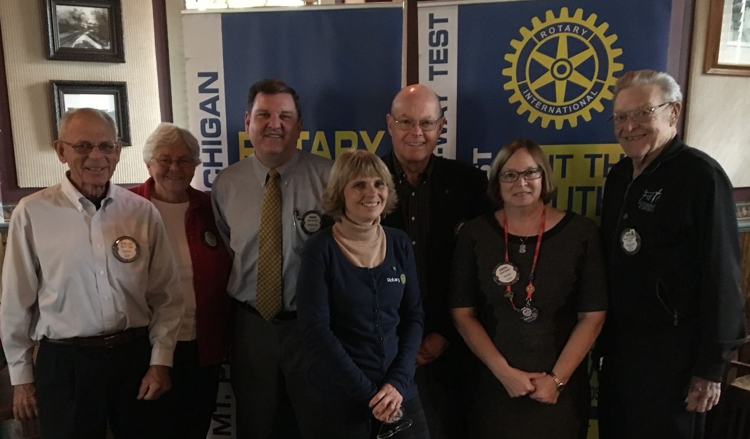
The Rotary Foundation has received a 4 star and the highest ranking from Charity Navigator. The foundation is broke up in to 3 funds- the Annual Fund, Polio Fund, and the Endowment fund. The annual fund invests 50% back to district and world projects after 3 years. Always choose Share to ensure the district receives funds. The polio fund is to end polio and has helped eliminate 99.9% of polio cases worldwide. The endowment fund is the bequest society and benefactors funds. Rotary also offers a Rotary Direct option for electronic giving and always choose “SHARE”.

