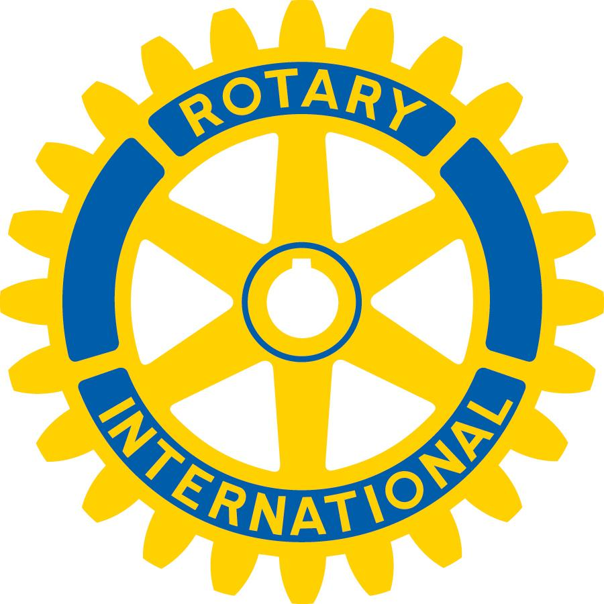
Mount Pleasant Rotary Club
P.O. Box 252
Mt Pleasant, MI 48804-0252
Website: mprotary.com
Facebook: Mt. Pleasant Rotary Club
Rotary Roundup
December 11th, 2017

Recap of December 4th, 2017 Club Meeting
Carol Santini called the meeting to order and lead us in the Pledge of Allegiance.
Invocation: Charlie Kinzel
Guests: Vanessa Sprat
Music: Kathy Beebe led us in “I’ve Been Working on the Railroad” and we sang Happy Birthday to Krystal.
Announcements:
- Paul is looking for volunteers to help him with the gift boxes. He needs one or two at a time to work in shifts of about 90 minutes.
- Eileen reminded us that next week is the Christmas party during our regular meeting time.
- Kathy Beebe mentioned that Rotaract had raised $1400 from their raffle ticket sale, but that Ken probably sold about half of them. The Rotaract group gets to keep half of that money for any community projects they do this year. Kathy also that she was having their Christmas party at her house.
- Carol passed along a thank you note to the Club from Girls on the Run.
- Bob Wheeler put envelopes for the Mount Pleasant Area Community Foundation on our tables as a reminder that we should donate to something at the Community Foundation and that our Club actually is an option there as well.
- Ken encouraged members to give $60 to Polio+ because that amount would immunize 100 children. On top of that the Gates Foundation will match it at a 2-to-1 ratio so your $60 can immunize 300 children!
- Carol reminded everyone that our next fundraiser is the Beef Dinner coming up in February.
Golden Apple Award: Randy announced that this month’s winner of the Golden Apple Award was Tammy Foltz, a bus driver for the Shepherd Public Schools. She was nominated by her loving husband. Congratulations, Tammy!
Sergeant-at-Arms: David Martin Stevens
Fines & Brags:
- A couple tables were fined for not being integrated.
- David fined Carol for insulting him.
- David Nicholas bragged about the upcoming Warm Hearts, Warm Homes fundraiser for home heating assistance coming up this coming Friday through Monday.

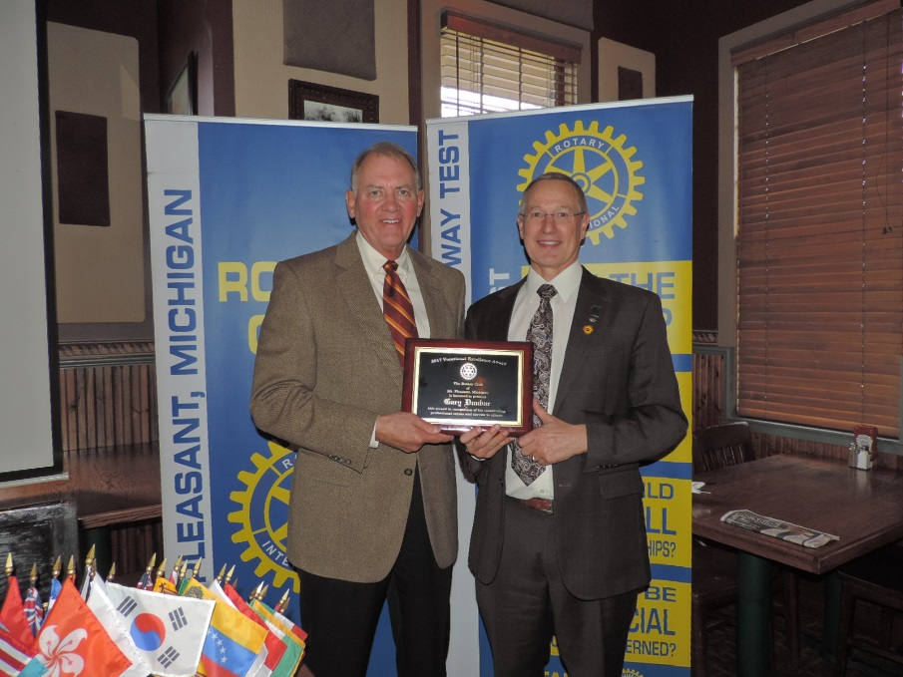
Vocational Excellence Award: Dave Keilitz presented this year’s Vocational Excellence Award to Gary Dunbar, a professor in the Health Sciences Building at CMU, for his work bringing and developing the neuroscience program. Under his leadership CMU offers neuroscience degrees at all academic levels and the B.S. program is even rated as the #1 program in the country. Congratulations, Dr. Dunbar! We are lucky to have you living in our community!

Program:

Dr. Jeff Inungu had his classification talk today. He was born in the Republic of Congo. He was one of ten children born to Christian parents who prioritized schooling for their children. He eventually went to medical school for pediatrics and was selected to teach at a new public health university in the Congo after he would complete his training in the United States. In the United States he earned his Ph.D. in Epidemeology & Public Health, but could not return to Congo because of civil war so instead went to Ghana. He was in Ghana for two years before returning to the United States where he then worked at a dizzying number of places both inside the U.S. and in Africa until the constant moving around became too stressful for his family, so he moved back to the United States one last time with his family and took a position on the faculty at CMU to teach public health policy. Welcome, Dr. Inungu.
