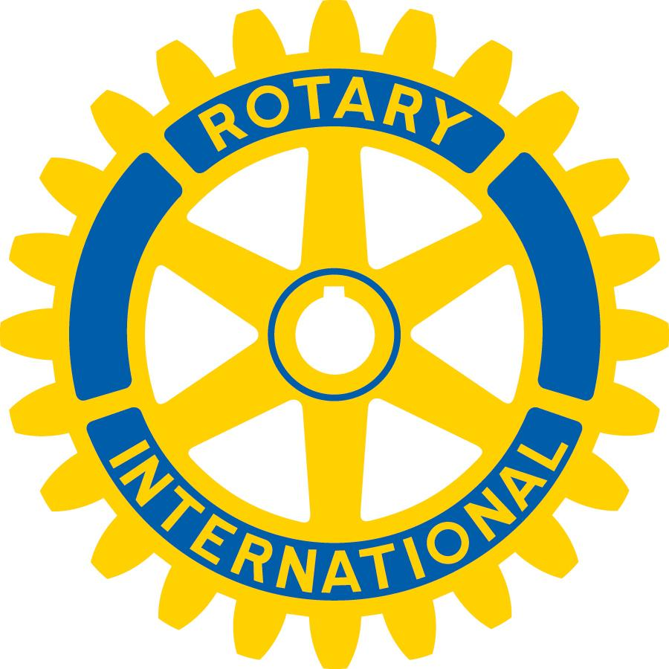
Mount Pleasant Rotary Club
P.O. Box 252
Mt Pleasant, MI 48804-0252
Website: mprotary.com
Facebook: Mt. Pleasant Rotary Club
Rotary Roundup
October 30th, 2017

Recap of October 23rd, 2017 Club Meeting
Carol Santini called the meeting to order and lead us in the Pledge of Allegiance.
Invocation: Paul Siers
Greeters:
Guests: John Hocrauf with Tom Miles, Stephanie Bird with Kathy Beebe, Judy Metcalf, Joyce Gluch
Announcements:
- Betty Rulong sent a thank you card for her husband – she found it very thoughtful and meaningful and greatly appreciated it.
- Dave reminded everyone of the distinguished citizenship and vocational excellence award, due in 2 weeks, please turn these nominations into Robin.
- Matt gave an update on the auction – over $14,000 was made – this included sponsorships. They will be auctioning off some of the remaining items at next week’s meeting.
- Carol would like feedback with regards to the auction – what works well, what needs to be looked at.
- Kathy talked about the Rotaract convention last weekend. It was an “amazing” event. There were great speakers, lots of student and team building. The students planned it out great; she hardly had to do anything.

Sergeant-at-Arms: Bob Wheeler

Fines & Brags:
- Peggy Pickler was fined because Bob’s plate was over-flowing at the Chocolate Fantasy fundraiser.
- Amelia was fined for hiding in the Rotary Club photo in the Legacy.
- Corey was fined for having fancy stars on his badge.
- Tom was fined for having his umbrella on the football field and for riding in a convertible during homecoming weekend.
- Robin bragged about her daughter’s wedding. It was perfect, her daughter is happy, the wedding was awesome and the Rockies are AMAZING.
- Amanda thanked all of the Rotarians that serve on the board for the Community Foundation (Jay, Dave and Bob).

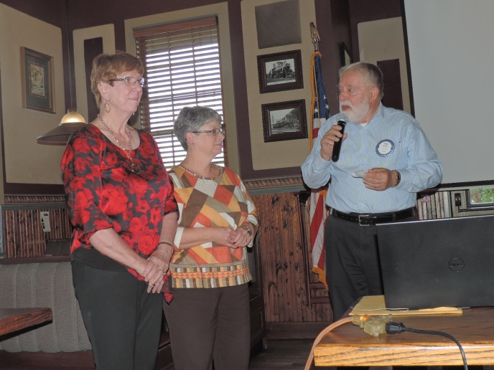
Zambia project: Paul introduced Judy and Joyce form the Shepherd Club. They were excited to be able to participate in an international project. They presented our club with a $1000 check for the Zambia project.

Program: Tom Miles from the Rotary Club and Shayesteh Jahanfel from the Central School of Public Health talked about Polio.

Polio invades the brain and spinal cord causing paralysis and possibly death.
In 1949 there were 42,000 cases of Polio, 2,720 people died – mostly children.
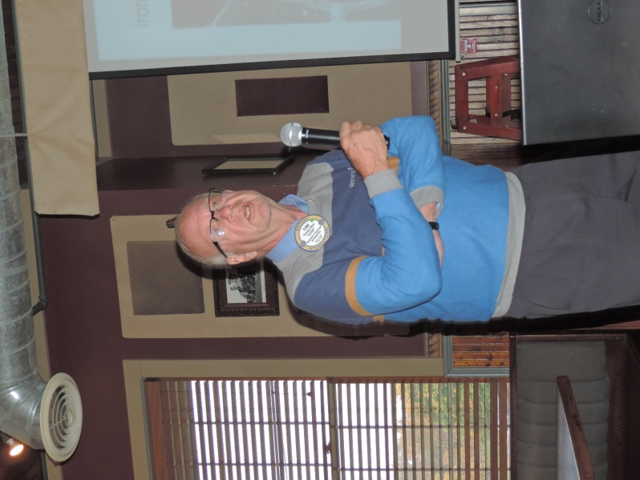
In 1955 Salk developed the first Polio vaccine, bringing Polio under better control throughout the 50’s and 60’s. Rotary has contributed over $1.7 billion and has immunized 2.5 million children in 122 countries. Club 6310 has been involved since the beginning in the eradication of Polio.

The only three countries that have had positive cases of Polio are Afghanistan, Pakistan and Nigeria.
2016 – 37 cases reported
As of October 2017- only 12 cases reported
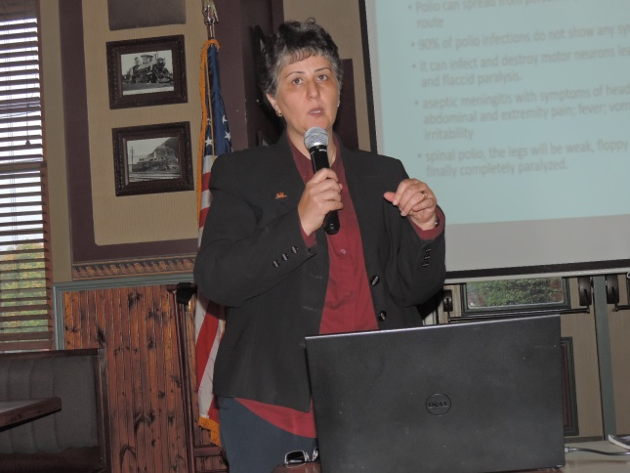

Iran is currently Polio free, however, due to their location in between Afghanistan and Pakistan – the 1 million refugees crossing their boarders pose potential risks that Polio will again enter their country and additional cases will come up. It is difficult in these counties to vaccinate; there are issues with people having access to healthcare. There are currently over 7 million children in need of vaccinations.

