Mount Pleasant Rotary Club
P.O. Box 252
Mt Pleasant, MI 48804-0252
Website: mprotary.com
Facebook: Mt. Pleasant Rotary Club
Rotary Roundup
March 19t^{h}, 2018

Recap of March 19th, 2018 Club Meeting
Carol Santini called the meeting to order and lead us in the Pledge of Allegiance.
Invocation: Charley Kinzel
Greeters:
Guests:
Music: Robin Duthie “Camptown Races”
Announcements:
- Amy Ervin: successful Fireside Chat at John Jensen’s house
- Mark Homuth: Beef dinner had a net profit of $17,313. Ticket sales were 19%, expenses down 18% and the total was up 42% over last year.
- Grants:
  - Chippewa Watershed
  - Cothing INC
  - Goodrow
  - Child Advocacy Council
- Bob Wheeler announced for Ken Schaffer that MP Rotary will support Rotary’s “The Year of the Tree, Rotary Plants for the Future” by planting 125 trees at a cost of $3500. The planting date will be announced. Be sure to bring your family to share in this community project.
- Alysha Fisher, President Elect, reported on the recent board training that she, Tom Miles and Eileen Jennings attended.
  - Upcoming theme: Be the Inspiration. the Force of Nature
  - There are 1.2 million members in Rotary. Although 2.2 million members have been inducted in the last 15 years, growth has been stagnant.
  - Initiative for next year includes enhancing the public image of Rotarians in the community.
  - There were only 3 cases of polio reported in 2018. The only other contagious disease to be eradicated was small pox.
- Ken Schaffer: Encourages every member to give a minimum of $26.50 to the Rotary Foundation before the end of the year.
- Bethany Ervin: Shared some highlights of Interact at Mt. Pleasant Middle School, which meets every other Wednesday at 7:00 am. They have 10 active students. Members, Abby Decker and Haily Henry reported that this year they have purchased clothes for the Foster Closet and tied blankets for the shelter.
- District Conference is May 4th and 5th

Fines & Brags:

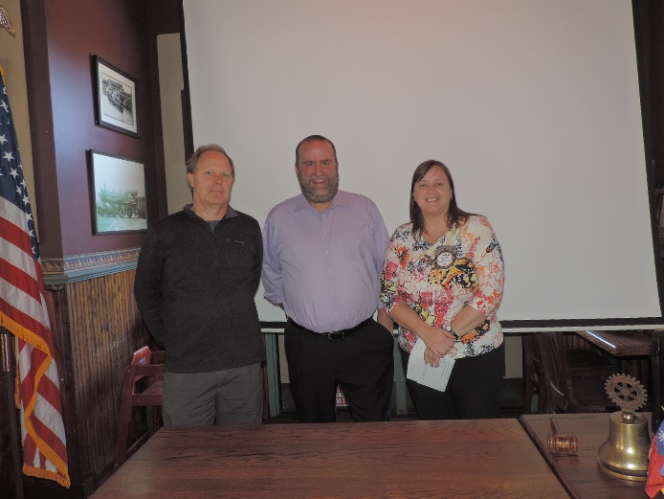
Program:
Amy Ervin did the induction of 2 new member- Jeff Platte, sponsored by Eileen Jennings and Charles Ulmer, sponsored by Charley Kinzel.

Student of the Month: Tom Gross introduced the Students of the Month and Jay Anders distributed the awards.
Jeff Platte from Mt. Pleasant High School introduced RJ Airoway who will attend Michigan Tech and Emily Otterkirk who will attend UNC in textile engineering.
Mary K. Yonker from Sacred Heart introduced Colton Hyble who will attend Grand Valley
and Superintendent William Chilman from Beal City introduced Katie Mathews who will attend CMU to major in athletic training.
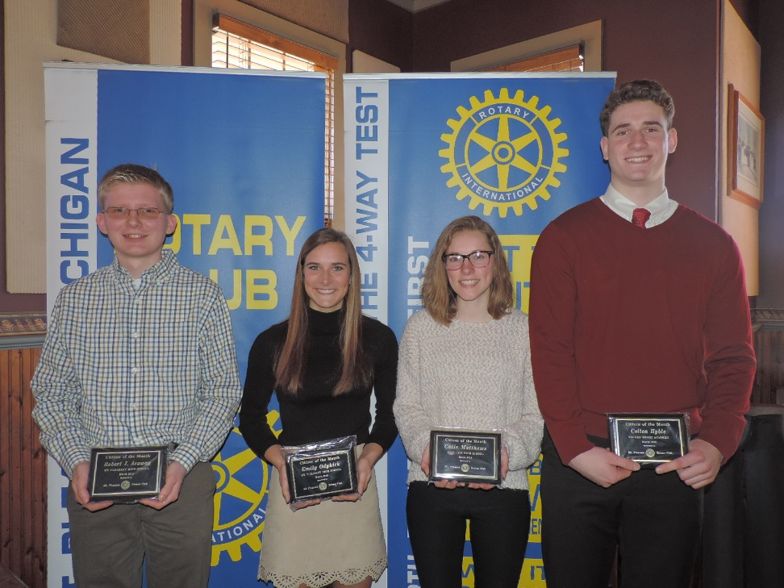
Congrats!

