Mount Pleasant Rotary Club
P.O. Box 252
Mt Pleasant, MI 48804-0252
Website: mprotary.com
Facebook: Mt. Pleasant Rotary Club
Rotary Roundup
January 8th, 2018

Recap of December 18th, 2017 Club Meeting
Carol Santini called the meeting to order and lead us in the Pledge of Allegiance.
Invocation: Charlie Kinzel
Guests: none
Election of officers: Jay Anders motioned and Tom Olver seconded the motion to elect the slate of officers put forth by Carol Santini. Motion passed unanimously.
Announcements:
- Beef Dinner will be in February. All of the fundraisers are being looked at this coming year to help improve efficiencies.
- Paul Siers talked a little bit about the $55,000 Zambia project and that a group would like to go in June. People could still get Michigan gift boxes through Saturday, December 23rd.
- Ken reminded everyone that they could donate to the Polio+ campaign on behalf of someone else as a gift.
Music: Kathy Beebe led us in “Joy to the World”
Sergeant-at-Arms: Tom Olver
Fines & Brags:
- Tom Olver bragged that American Mitsuba raised more than $13,000 for the United Way last year.
- Paul bragged that his daughter earned her M.S.A.
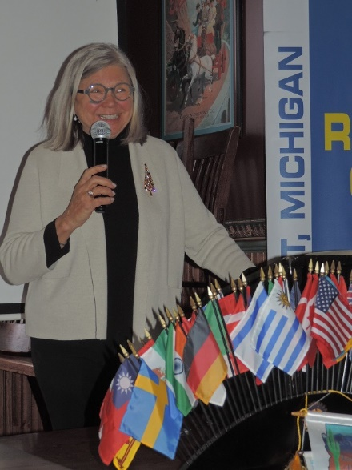
- Charlie bragged that he had 25 family members at his house.
- Peggy informed us that 2,160 people had benefited from Christmas Outreach this year.
- Kim said that she and her daughter were leaving for Paris and London and that her son is also doing very well in school.
- Ken gave us a recap of the latest Rotarian magazine.

Program:
Our program today was a two-parter. First we had the presentation for the Rotary Citizen of the Year followed by our Student Citizen of the Month presentations. Amanda presented the Rotary Citizen of the Year Award to a much deserving Jan Strickler who is a CMU graduate who worked for Blue Cross Blue Shield for 27 years after which her real work began as she started volunteering all over Isabella County and serving on numberous boards. Thanks for all your years of service to our community, Jan!
We had three deserving students this month for our Student Citizen of the Month Awards. From the Mount Pleasant High School we had Peter Smith who will be going to either Michigan Tech or the U.S. Naval Academy for engineering, and Kennedy Griffin who will be joining the U.S. Marine Corp as a career Marine specializing in either civil engineering or criminal justice. From Sacred Heart Academy we had Grace Reetz who will be going to Hope College for an undergraduate degree in either biology or psychology before she goes on to medical school.
