Mount Pleasant Rotary Club
P.O. Box 252
Mt Pleasant, MI 48804-0252
Website: mprotary.com
Facebook: Mt. Pleasant Rotary Club
Rotary Roundup
December 4th, 2017

Recap of November 27th, 2017 Club Meeting
Carol Santini called the meeting to order and lead us in the Pledge of Allegiance.
Invocation: David Stevens
Greeters: Connie Lynch and David Stevens
Guests: Bonnie Schaeffer, wife of Ken Schaeffer, Scott Campbell, husband of Krystal Campbell, Cindy Lutz visiting Rotarian and Guest of Kathy Beebe. Lynn Hoerauf guest of Jon Hoerauf.
Music: Eileen Jennings led us in Happy Birthday to Amy Ervin and Kara Lynch and “If Your Happy and You Know it”.
Announcements:
- Carol Santini announced that Alysha Anders Fisher will be out new President Elect and we are still looking for a President Elect Elect.
- Paul Siers reminded us orders are able to be placed for the Michigan Gift Boxes- Only 3 more Mondays til Christmas. There are two sizes- a $20 five item box and a $35 nine item box. These purchases support local businesses.
- Kathy Beebe thanked us for supporting the Roterac Club last week by purchasing Super Bowl Tickets and she has more if anyone is interested.
- Eileen Jennings announced the Christmas Party will be December 11th. There will be fun and games. Please bring a Christmas card for the lunch card exchange and get and give lunch with a fellow Rotarian.
- Connie Lynch let us know of volunteer opportunities this Friday and Saturday December 1st and 2nd for the Mt Pleasant Christmas Celebration. Contact Melinda Salchert at 989-779-5349 if you are interested in helping.
- Kara Lynch also announced that she is the volunteer coordinator at the Hospice House and they are looking for volunteers to help decorate for Christmas.
- Ken Schaeffer reminded us to give to the Foundation and he has the envelope.
- Eileen Jennings let us know the Christmas Outreach is also needing volunteers for Tuesday and Wednesday from 8:30 to 3pm assembling stockings at Finch Fieldhouse. They still need volunteers for distribution as well. Call 989-317- Tree to register to volunteer.

Sergeant-at-Arms: Tom Olver who didn’t show up so Bob Wheeler filled in. (Reminder to fine Tom next week)
Fines & Brags:
- Bill Mrdeza was fined for having the grumpiest look on his face during the song “If Your Happy and you Know It”.
- Eileen was fined for her Christmas Outreach Announcement. Peggy Burke invited us all to the Christmas Outreach Open house December 7th from 5-7 PM for cake and punch. She also thanked Bonnie Schaeffer for all her years of service (About 35) doing Christmas Outreach registration.
- Bethany Ervin bragged that her 4 your old son will be in the Little Dickins Christmas Celebration of Charlie Brown Christmas this weekend and next at the Broadway.
- Amanda Schafer reminded us that this Tuesday is Giving Tuesday. The community Foundation is attempting to raise $25,000 for the 25th anniversary of the Youth Fund. Donations can be made online.
- Ken Schaeffer bragged his wife who he Married 65 years ago today.

Program:
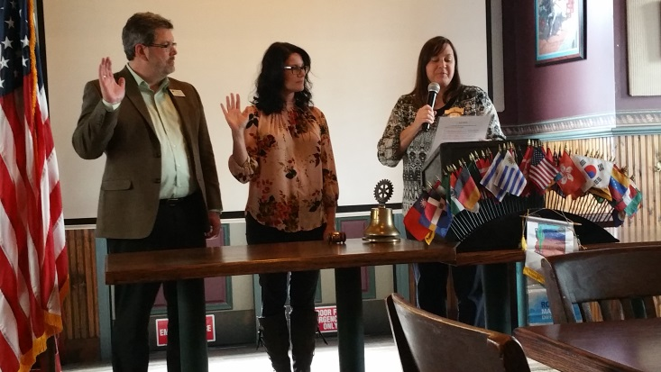
Amy Ervin did the induction of 2 new members- Kara Lynch, sponsored by Connie Lynch and John Hoerauf who was sponsored by Danielle Peterson.

Carol Santini presented Dr. Christine Hammond, the 6th President for MidMichigan Community College. She is a Rotarian in the Clare Club and helping to start a Rotary Club in Harrison.
She spoke on the history of MidMichigan College which became a community college with the State of Michigan in 1965. They served Clare and Gladwin Counties until 1969 when they began working in Isabella County. They pride themselves with offering access and affordability to all the students of the counties they serve. All are accepted to their school and classes cost 1/3-1/2 of the cost of the instate 4 year colleges. They currently serve 4 counties as part of the Great Lakes Bay Region.
Dr. Hammond is proud of their integration with high schools serving approximately 900 students in early college programs. These allow students to complete a 5th year in high school at which time they graduate with a diploma and associates degree.
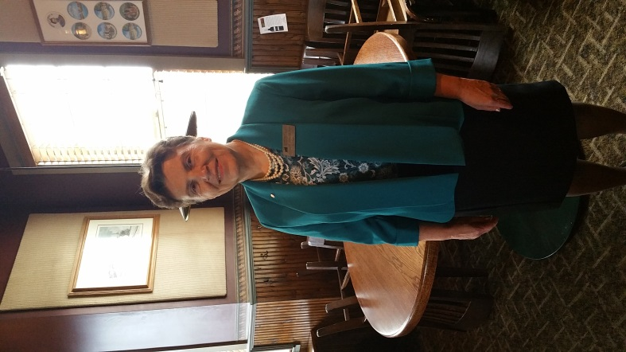
Mid Michigan also boasts an international program which is unique for a community college to have. Across the country there are approximately 740,000 international students from Asia which is 200,000 more students than currently attend all the colleges in Michigan. International students are approximately 21% from China, 12% from India, 8% from South Korea, 6% from Saudi Arabia, 3% from Canada, 2% from Taiwan and Japan. Mid works closely with Japan and our sister city there with student exchanges programs and study abroad programs.
Dr. Hammond is currently working on new mission and vision statements for the school. She feels current enrollment is looking good. She finds a large need to partner with 4 year colleges to allow students to complete certain degrees (Particularly RN- BSN programs). She finds the current funding status discouraging as they are 9% funded by property tax, 19% by the state and 72% by student fees which is not comparable to similar intuitions but unlikely to change.

