Mount Pleasant Rotary Club
P.O. Box 252
Mt Pleasant, MI 48804-0252
Website: mprotary.com
Facebook: Mt. Pleasant Rotary Club
Rotary Roundup September 25, 2017

Recap of September 18th, 2017 Club Meeting
Carol Santini called the meeting to order and lead us in the Pledge of Allegiance.
Invocation: Bob Wheeler
Greeters: Bethany Ervin & Jena Eisenberger
Guests: Elizabeth Groeahout and Megan Potts

Announcements:
- Dave Keilitz is being awarded the Dick Enberg CMU Alumni Commitment Award
- The Rotary Run 5K raised $2,000 for the club. Large t-shirts are still available for purchase if anyone would like one. They are $15.
- Rotaract is hosting the Michigan conference for Rotaract clubs this year. Other project they have planned this year are planting flower beds, providing planters for nursing homes, and doing renovations at the Women’s Shelter. They will be selling raffle tickets as a fund-raiser in the near future.
- Interact had their first meeting of the year this past week. They meet the 2nd Friday of the month at 7:15 AM. The group of 20-25 students will be volunteering at the homeless shelter once the season starts this year.
- Kathy and Krystal have been working with the Interact members at the Mount Pleasant Middle School, but Rotaract members will be taking over that roll in the near future.
- Ken pointed out the the Bill & Melinda Gates Foundation has given $415,000,000 to help us eradicate polio.
- Paul has two different levels of our Michigan gift boxes this year-A deluxe box for $35 and a Mini-MI box for $20. Each box has a mix of similar and unique items so it would be worth it to get both for those you REALLY appreciate. They will start taking orders on October 1, but let Paul know ahead of that date if you are interested.
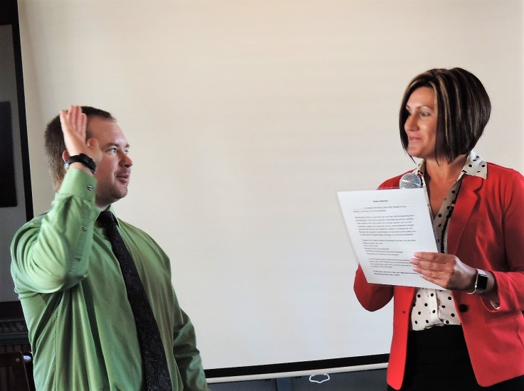
- Matt is collecting items for the Rotary Auction until September 30th.

New Member Induction: Patrick Carrick from FEMA was welcomed into membership!

Music: Robin Duthie led us in “The Battle Hymn of the Republic”.

Sergeant-at-Arms: Peggy Pickler

Fines & Brags:
- Robin was fined for leading us in a song that was in the songbook, but not passing out the songbooks.
- Eileen reminded everyone to bring the free calendars they get in the mail and travel-size bottles of personal hygiene products for Christmas Outreach.
- Amanda informed us that the Women’s Initiative event “Look Who’s Talking” is coming up on October 10th. The cost is $45.
- Kathy bragged that her 9 year old granddaughter got her first buck during this year’s youth hunt.
- Jasmine said she had a lot of fun at the Rotary Run this year.
- David bragged that the Mount Pleasant Extreme boys team is 2-0 so far this year.
- Bethany let us know that the Chamber Singers Ensemble, of which her son is a member, is having their Cabaret fundraiser on October 10th.
- Rebecca informed us that a service for the Schaefer family that was killed in the car/bus accident will be at Sacred Heart.

Program:

Jennifer Verlager gave her classification talk today. Jennifer is the new Superintendent of the Mount Pleasant Public Schools. She started out as a school counselor in 1997 and worked her way up. Before working for the MPPS though she worked in college admissions at Aquinas College. She moved around a lot when she was a kid because her dad worked for General Motors and moving was the only way to get a promotion at the time. Both she and her husband, Mike, went to CMU. Mike grew up mostly in Kalamazoo. They have a son and a daughter who are three years apart.

Jennifer also wanted to give us an overview of the facilities projects that are going on in the schools since the passing of the latest bond:
- New classrooms
- Drinking fountains now have water bottle fillers
- Auxiliary gym at the middle school
- New playgrounds at all the elementary schools
- McGuire got a new office area and computer lab
- Pullen has a new office and 2 new classrooms
- Fancher is getting 8 new classrooms
- All other schools had remodeling of some form completed
- Eight new buses were purchased

