Mount Pleasant Rotary Club
P.O. Box 252
Mt Pleasant, MI 48804-0252
Website: mprotary.com
Facebook: Mt. Pleasant Rotary Club
Rotary Roundup
March 12th, 2018

Recap of March 5th, 2018 Club Meeting
Amanda Schafer called the meeting to order and lead us in the Pledge of Allegiance.
Invocation: Jeff Inungu
Greeters: Alysha Anders-Fisher and Jay Anders
Guests: Charles Ulmer guest of Charlie Kinzee and Al Slaggert from the Clare Club.
Music: Kathy Beebe led us in “We Are Rotary.”
Announcements:
- Jasmine Eichinger needs volunteer readers for reading at the elementary schools during March. Contact her if you are interested. We have hopefully 19 classrooms we will be reading to.
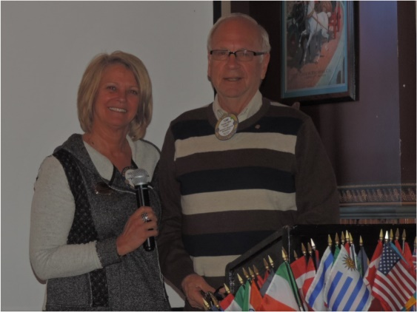
- Siv Narayan let us know we will have 2 outbound students- Josaphine and Angelina who attended the orientation meeting in Midland for the Youth Exchange. We also found out our inbound student will be from Japan and likes cooking, cleaning and they could still need 2 more host families. She arrives in August and Bethany Ervin will host first.
- Randy Dickinson announced our last 2 Golden Apple Award winners- Deanna Yager of Farwell and Wendy Lemke.
- Paula Arndt presented a Paul Harris 7 to Tom Miles. Thank you Tom for all your support of Rotary!
Sergeant-at-Arms: John Jensen
Fines & Brags:
- Fined Bethany Ervin for receiving the well deserved Eagle Award. Congrats Bethany!
- Fined Tom Miles, District Governor Elect for his confusing email.
- David Nicholas bragged for Wendy Lemke as his son nominated her and she is great, also for the 6th Grade basketball team and for all the Law Enforcement and 1st responders who kept the community safe during the manhunt on Friday.
- David also let us know the Rotary Club of Saginaw has a program at Apple Mountain coming up- details are available at Saginawonstage.com.
- Rich Divine bragged for the CMU Mens and Womens basketball teams who are both in MAC tournaments.
- Peggy Burke bragged for Jennifer Verleger and how great the schools response was on Friday and how safe the students felt during the incident.
- Paul Siers bragged for Siv who has been responsible for gathering the interest in the inbound and outbound Youth Exchange Students.
- He also let us know the trip to Zambia will be happening and Siv can’t go because he is presenting a paper in Malta. Congrats and thank you Siv for all your work for Rotary.
- Don Hire bragged that Sacred Heart had to cancel and lock down for the Friday Fish Fry. In turn they fed all the students who’s parents were unable to pick them up from the school.
- Amanda Schafer fined herself for wrinkling Tom Miles perfect attendance award in her purse.
- John had a trivia question letting us know 20% of Eagle award winners have been Rotarians- 12 different Rotarians.
- Bob Wheeler bragged for the Community Foundation who increased assets by 2.6 million.

Program:
Tom Miles presented Sheila Carroll a professional Story Teller. She has 2 masters’ degrees and is in what she calls her 3rd act of life as a Story teller coach. She tells us it doesn’t matter how old you are.
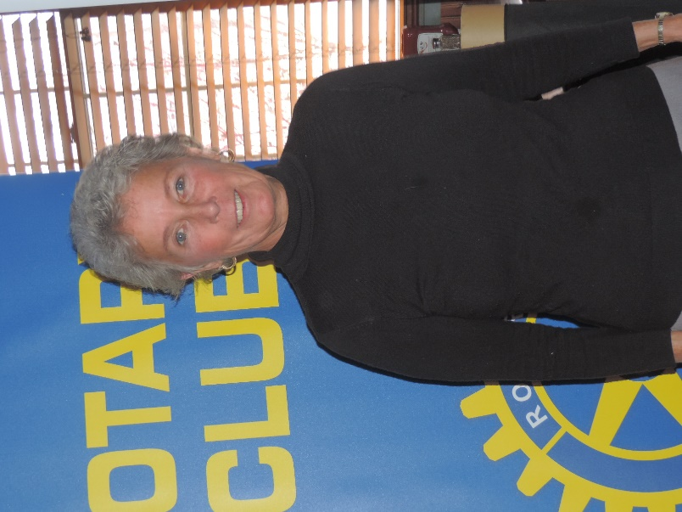
She gave us a story regarding a Poor Little Boy and all he could do. Brian O’Donnell- to become A Storyteller- The Story of the Boy Who Had No Story.
She lives by the motto- there are 2 things important in life- what really matters and then everything else.
She then spoke on what really matters. To know, embrace and to commit to what really matters and to live your story- not someone else’s.
She told us her story. She grew up in Saginaw by the river. As she got older she started believing others story’s- believing what she couldn’t do. Something she wanted to be was a poet. Her dad said women only can be a secretary, nurse or teacher. She decided to be a teacher then. She loved children but hated the educational system. She got laid off and went back to school. She came to Mt. Pleasant for the Children’s Literacy Program and heard a storyteller and fell in love with storytelling.

She told us all not to ignore your story. You feel the story tug on your heart. When thinking about your story think of your earliest memories, who you admire (she admires JL Callaghan), what is your defining moment and then commit to it and live it.

