Mount Pleasant Rotary Club
P.O. Box 252
Mt Pleasant, MI 48804-0252
Website: mprotary.com
Facebook: Mt. Pleasant Rotary Club
Rotary Roundup August 21, 2017

Recap of August 14th, 2017 Club Meeting
Amanda Schafer called the meeting to order and lead us in the Pledge of Allegiance in Carol’s absence.
Invocation: Bob Wheeler
Greeters: Kathy Beebe and Krystal Campbell
Guests: Al Slaggert, Paul Snider guest of Don Hire and Peter Edku, Rotary Global Scholar.
Announcements:

- Peter gave an update of his current status in life.
- Bob Wheeler reminded everyone who owes money to pay up
- Jena Eisenberger reminded us the Rotary Run is in two weeks. Still in need of additional registrations and sponsors for the event.
- Matthew Hagen reminded us about the Rotary Auction, which will be October 17th. Call sheets will be coming.
- Club picnic will be September 11th.

Music: “Happy Birthday” to Bob Wheeler and Mark Homuth and “Take me out to the Ball Game” led by Bethany Erivn.

Sergeant-at-Arms: John Jensen

Fines & Braggs:

- Tom Olver has exceeded his 200 mile goal for raising money for Isabella and Gratiot County Back to School drive. They have raised and are about to distribute 50K in school supplies. Thank you to all that sponsored and there is still time to help if you are interested.
- Amy Powell talked about Art Walk Central upcoming events. You can find a month long list of events online.
  - The annual auction will be held at the end of the month
- Jena invited us all to a Women’s investing seminar this Thursday at Hunters Ale House.
- Krystal is selling Mt Pleasant Athletics booster discount cards if you are interested see her. She is also celebrating her 20th wedding anniversary. Congrats Krystal.
- Kim Seidel invited us all to join Sam’s Club to support CAFÉ at the Pines Golf outing August 19th.
- Connie Lynch asked we keep the softball catcher in our prayers as she embarks on a battle with cancer.
- Ken Schaeffer bragged about Tia completing her summer internship and that GM has promised her another one next year in the design department.
- John Jensen bragged that 60 years ago he asked his wife to marry him. Congrats!

Program:
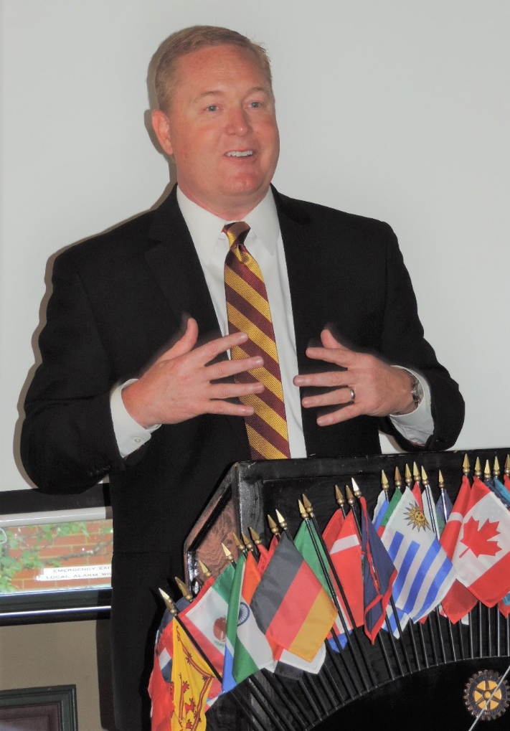
Dave Keilitz introduced Michael Alford, the new athletic director for Central Michigan University. He started July 3rd. He has relocated to Mt Pleasant with his wife and 3 daughters. He was born and raised in eastern Tennessee. He has worked many Division 1 schools, played division 1 ball and worked for the Dallas Cowboys for 6 years. He then returned to the college arena completing 160 million dollars in facility upgrades at the University of Oklahoma. CMU called and he felt they aligned well with his current goals. He loves the coaching staff at CMU and President Ross.

He is helping undersee the restoration project to CMU from recent flooding where the Student Athletic Center and the baseball lockers were the worst hit of his facilities. He does not currently feel there are any missing sports from the CMU line up. He does feel that the football facilities are in need of upgrades to bring current to the times as most of it is original 1970s construction. The rest of the facilities are second to none. He plans to focus on recruitment and revenue. He is currently working on the football schedule for 2 years out and assessing for additional needs. He works with the goal of making sure students experience at CMU is the best 4 years of their lives.

Photos Compliments of Kathy Beebe

